D365 Finance & Operations – DMF Package Import API Sequence Documentation
This document provides a clear, step-by-step explanation of the Data Management Framework (DMF) Package Import API sequence used for integrations in Dynamics 365 Finance & Operations (D365FO).

1. Overview
Dynamics 365 Finance & Operations provides the Data Management Framework (DMF), which includes a REST-based Package API designed for importing full data packages programmatically.
A DMF import package consists of:
- PackageHeader.xml
- Manifest.xml
- Data files (CSV/Excel etc.)
- Zipped as a single .zip
The DMF API allows:
- Uploading a package to Azure Blob Storage
- Triggering an import
- Checking execution progress
- Retrieving any import errors
This integration sequence is required for Logic Apps, Azure Functions, ADF pipelines, or any external systems sending data into D365FO.

2. Visual Summary of the DMF Import Flow
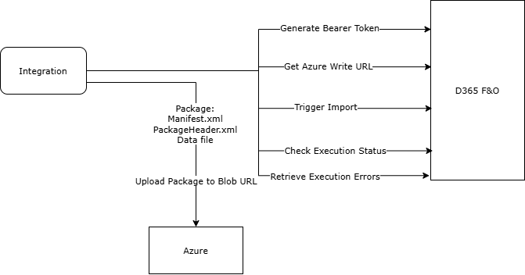

3. End-to-End DMF Package Import API Sequence
The complete sequence involves five API steps.

STEP 1: Generate Write URL (GetAzureWriteUrl)
This API generates a secure SAS URL where the .zip package must be uploaded.
Endpoint:
POST /data/DataManagementDefinitionGroups/Microsoft.Dynamics.DataEntities.GetAzureWriteUrl
Body:
{
"uniqueFileName": "yourPackageName.zip"
}
Purpose:
- Returns BlobUrl with SAS token
- Required for Step 2
STEP 2: Upload Package to Blob Storage (PUT)
The zip package must be uploaded to the BlobUrl returned in Step 1.
Method: PUT
Headers:
x-ms-blob-type: BlockBlob
Content-Type: application/zip
Purpose:
- Uploads the final package into D365-associated blob storage
STEP 3: Initiate Import (ImportFromPackage)
This API triggers the actual DMF import job.
Endpoint:
POST /data/DataManagementDefinitionGroups/Microsoft.Dynamics.DataEntities.ImportFromPackage
Body:
{
"packageUrl": "<BlobUrl-from-Step-1>",
"definitionGroupId": "YourDefinitionGroup",
"executionId": "",
"execute": true,
"overwrite": true,
"legalEntityId": "USMF"
}
Purpose:
- Starts the DMF import job in D365FO
- Creates a batch job for the selected definition group
STEP 4: Check Status (GetExecutionSummaryStatus)
This API allows polling for execution progress.
Endpoint:
POST /data/DataManagementDefinitionGroups/Microsoft.Dynamics.DataEntities.GetExecutionSummaryStatus
Body:
{
"executionId": "<executionId>"
}
Purpose:
- Returns: NotStarted, InProgress, Succeeded, Failed etc.
STEP 5: Retrieve Errors (GetExecutionErrors)
If the import fails or partially succeeds, this API retrieves all error details.
Endpoint:
POST /data/DataManagementDefinitionGroups/Microsoft.Dynamics.DataEntities.GetExecutionErrors
Purpose:
- Extracts entity-level and record-level validation issues

4. Requirements for the Integration
Authentication (OAuth 2.0)
- Azure AD App Registration
- Client ID + Secret
- Bearer token required for every API call
Package Requirements
Your .zip must contain:
- Manifest.xml
- PackageHeader.xml
- All data files
Files must match Data Project definition
- Entity mapping
- Column names
- Legal entity assignments

Customized entities provide additional detail as follows:
- ACCDMFExecutions – Uses DMFExecutionSummaryStatus to determine whether the execution has succeeded and, based on the executionId, retrieves the journal batch number when successful.
- ACCDMFStagingValidationLogs – Retrieves detailed error messages linked to the executionId.

